National University of Technology

Computer Science Department
Semester Fall - 2024
LAB - 01
Course: Information Security Lab
(CS-23-B)
Course Code: CS291
SUBMITTED TO:
MA’AM ZAINAB IFTIKHAR
Computer Science Department
SUBMITTED BY:
Name: MIAN SHAKAR AFZAL
Registration No: F23605073

TASKS
QUESTION 1:
Write VM Benefits: Summarize why a VM is ideal for information security experiments, especially for tasks like malware testing.
Solution:
Virtual machines (VMs) offer a secure and flexible environment that is ideal for conducting information security experiments, particularly in the domain of malware testing. By creating isolated instances of operating systems, VMs allow researchers to execute potentially harmful software without risking damage to the host system.
This containment ensures that any malicious behavior, such as data breaches or system compromises, is confined to the virtual environment. The rapid provisioning and spoiling capabilities of VMs further facilitate iterative testing; experiments can be quickly reset to a clean state after each test run, enabling repeated trials with different variables.
Additionally, VMs can replicate various operating systems and configurations, making it easier to study malware's behavior across diverse environments.
As a result, virtual machines not only enhance safety and control but also accelerate the research process, ultimately leading to more effective security measures and a deeper understanding of potential threats in the cybersecurity landscape.

UBUNTU INSTALLATION PROCESS
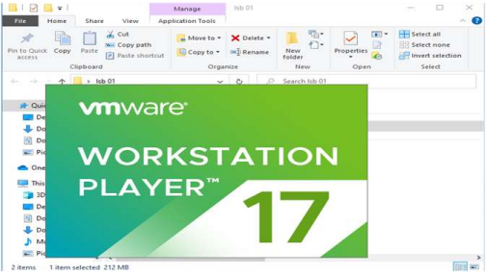

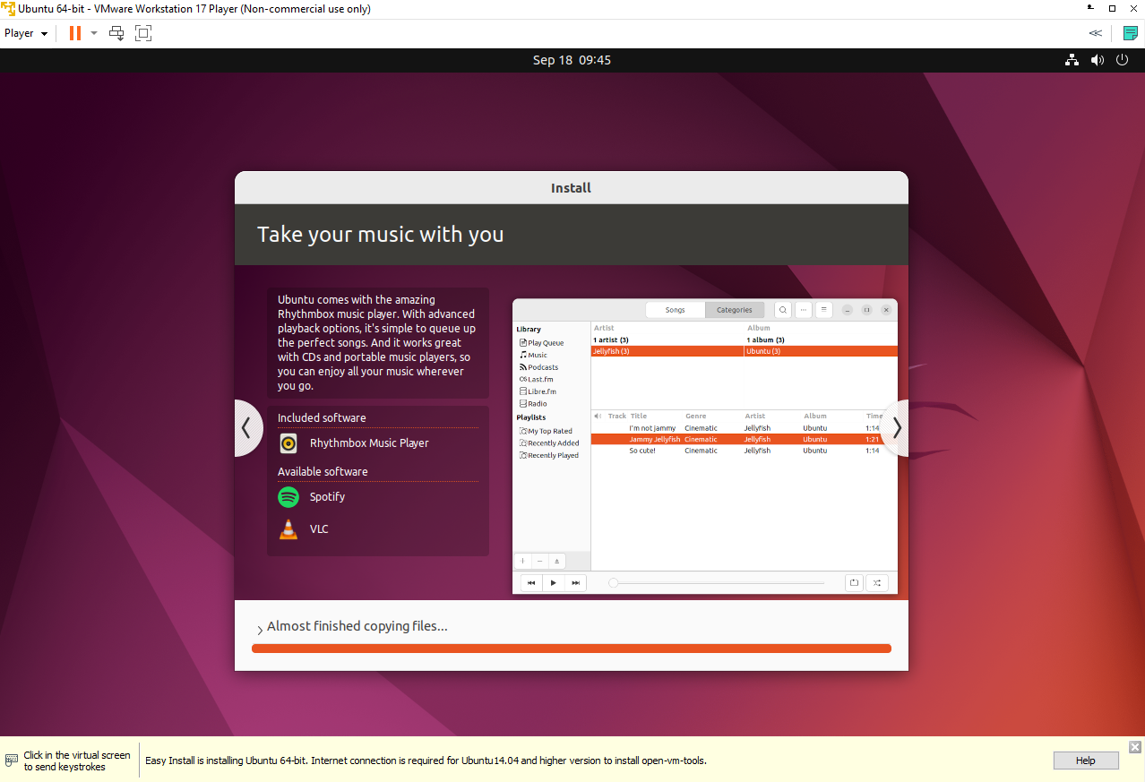

FIRST COMMAND
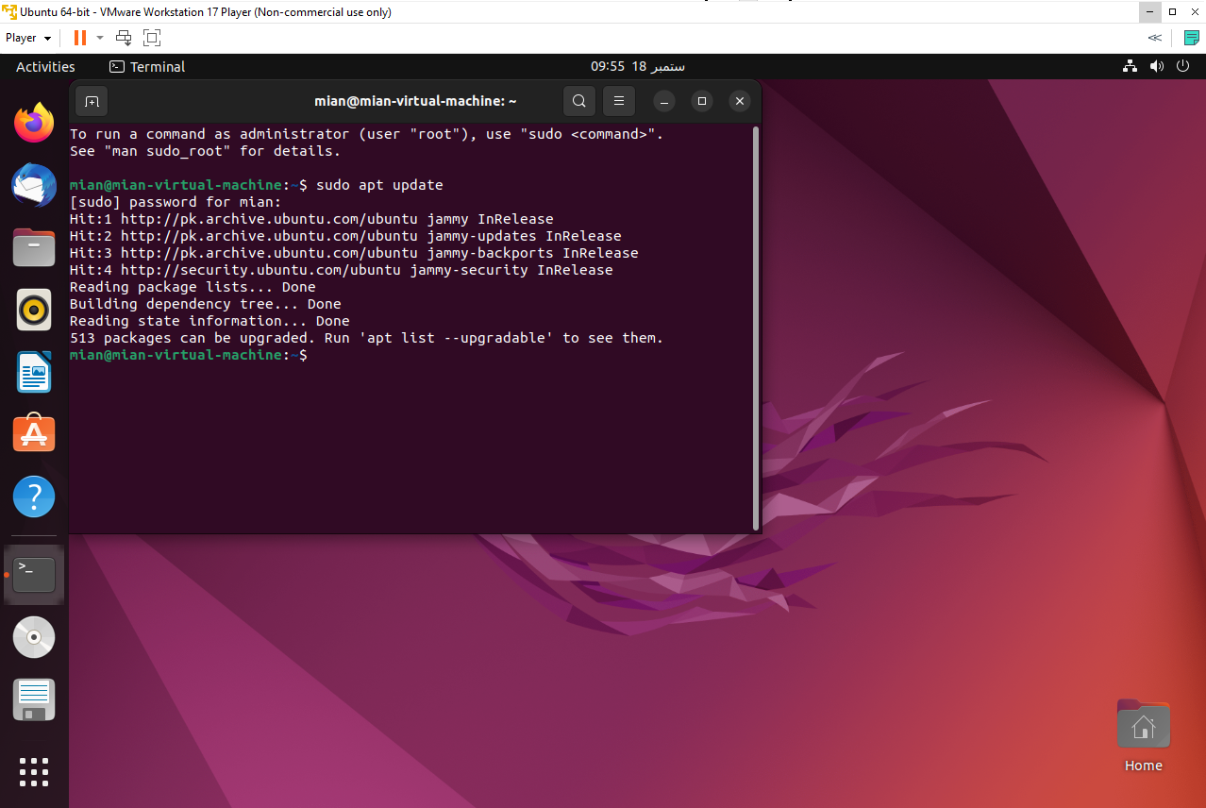
- Sudo apt update: This command updates the package lists for upgrades and new installations.
- It ensures you have the latest information about available software.

SECOND COMMAND
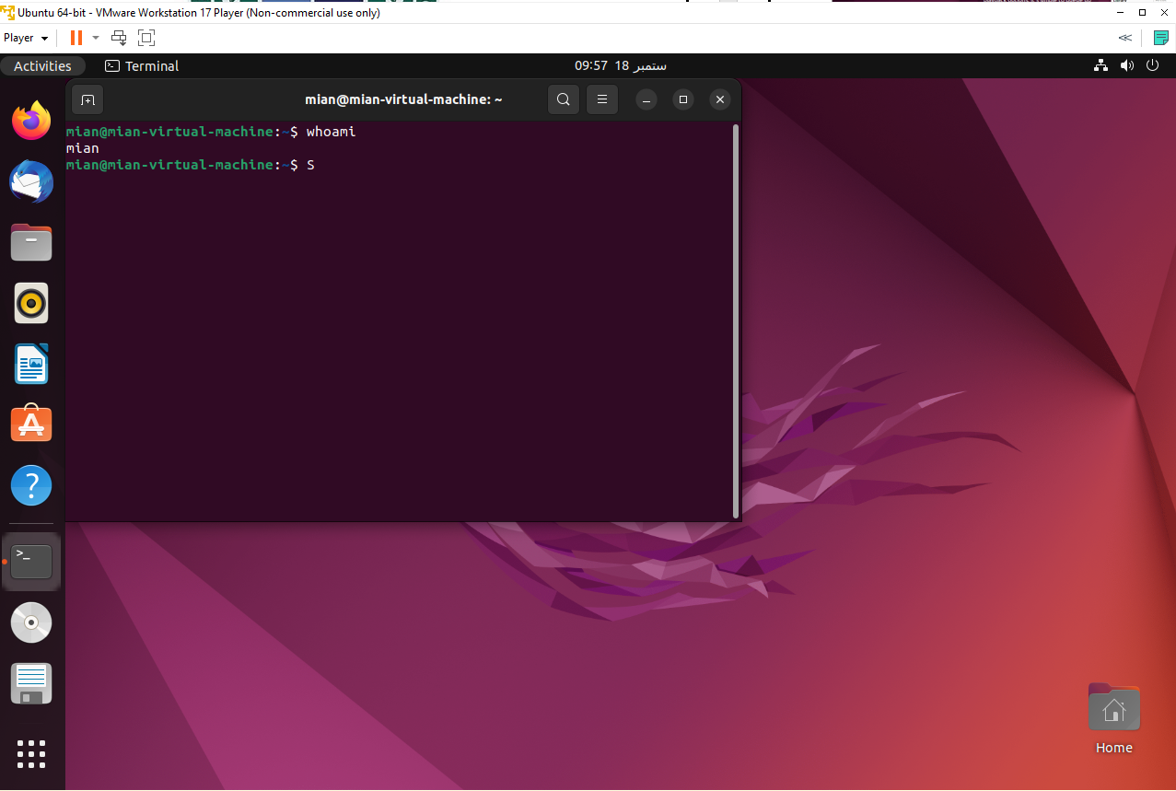
- whoami: Displays the current logged-in user’s username.
- It is useful to confirm under which user account you are operating.

THREE COMMANDS
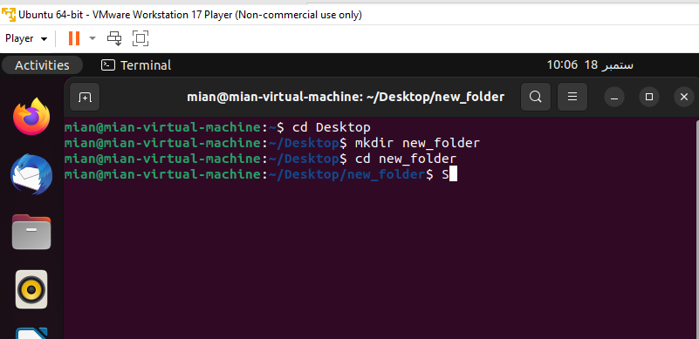
- cd Desktop: Changes the current directory to the Desktop folder.
- It allows you to navigate to the Desktop to access files there.
- mkdir new folder: Creates a new directory named “new folder.”
- This is useful for organizing files into separate folders.
- cd new folder: Changes the current directory to “new folder.”
- It lets you move into the newly created directory to work within it.

THREE NEW COMMANDS
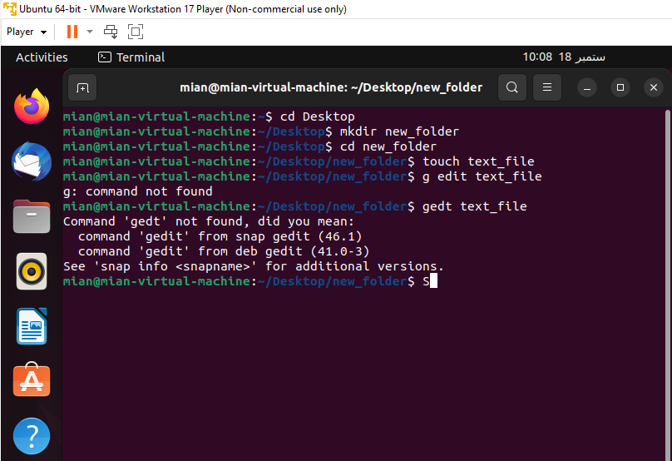
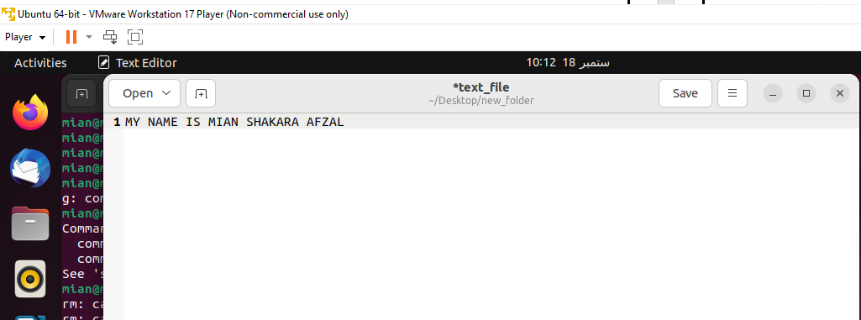
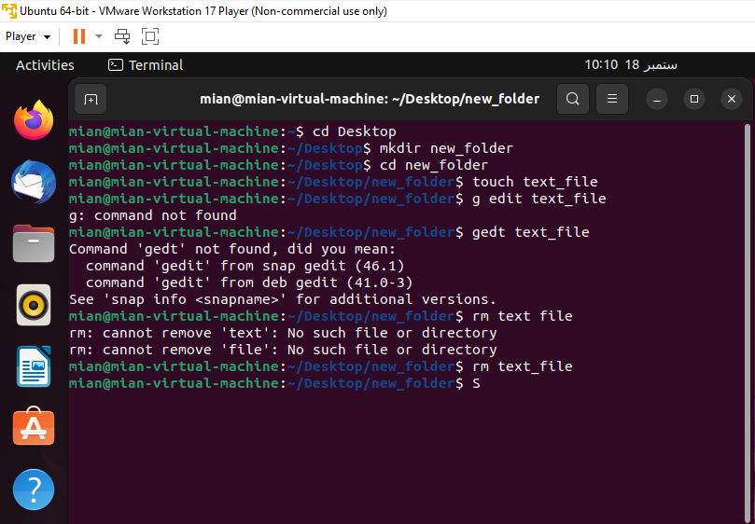
- touch text file: Creates an empty file named “text file.” This is often used to quickly create new files.
- cp text_file.txt /path/to/new directory: Copies “text_file.txt” to the specified directory.
- It is used for duplicating files to various locations.
- gedit text_file: Opens “text_file” in the gedit text editor.
- This allows you to edit the file’s contents.
- rm text file: Deletes “text file.” It is used to remove files you no longer need.

DATE COMMAND
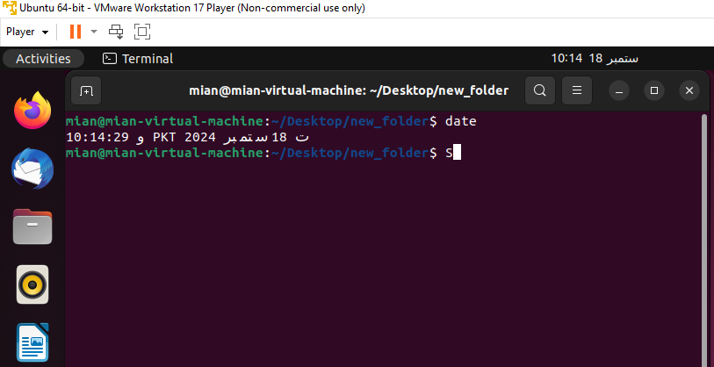
- Date: Displays the current date and time.
- Useful for checking the system’s date and time settings.

AUX COMMAND
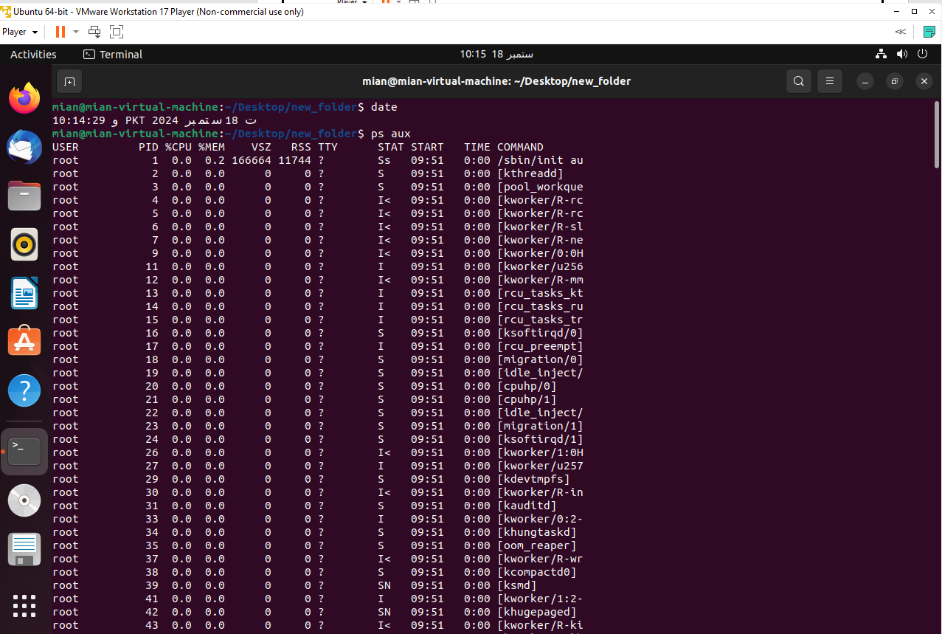

- PS aux: Displays a detailed list of all running processes.
- It helps you monitor system activity and resource usage.

Df-h COMMAND
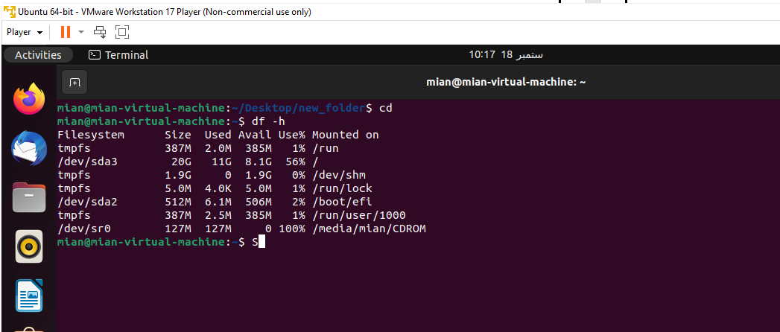
- df -h: Shows disk space usage in a human-readable format.
- It is useful for checking available storage space.
HISTORY COMMAND
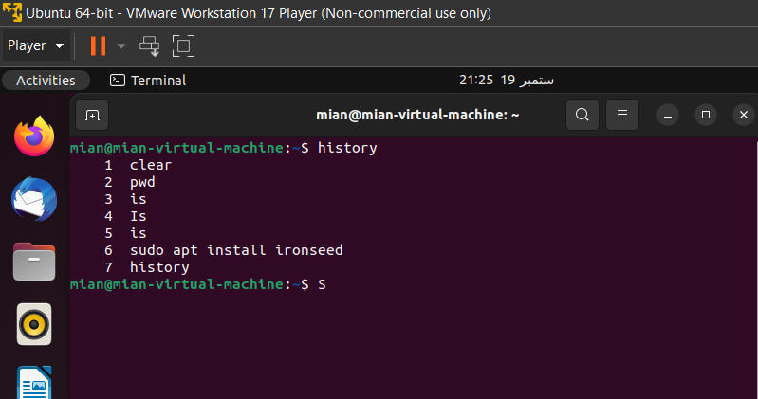
- history: Shows the list of previously entered commands.
- This is useful for recalling and reusing past commands.
CD AND CD... COMMANDs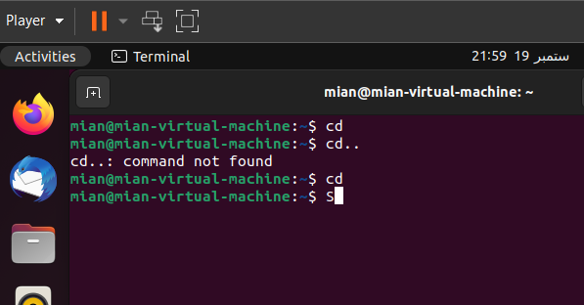
cd ...: Moves up one directory level. This helps you navigate back to the parent directory.
- cd: Changes to the home directory. It is a quick way to return to your main user directory.
CLEAR COMMAND
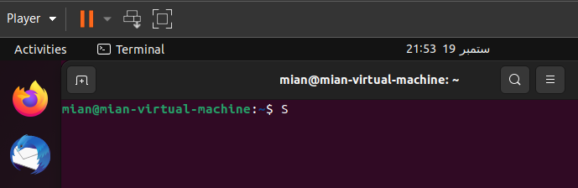
- clear: Clears the terminal screen once more, ensuring a clean workspace.

